Version 2.1.3

Tube Preamp 2.1 Add-on PCB
It is HIGHLY recommended that you read through all this documentation before undertaking this project. Don’t let the size of this document scare you though, I just made few assumptions and tried to share the experience I had in as much detail as possible regarding this build. If you are already experienced with building DIY pedals and getting them mounted into enclosures, you are well on the way to a successful build.
The Frog tube preamp is based on the preamp section of the iconic Fender Dual Showman of the late 60’s which was famous for its clean powerful tone. The folks at Alembic started producing a rack mounted version of this preamp in the 70’s. It could be found in the racks of guitarists like David Gilmour and Phil Lesh and bassists like Bootsy Collins among many others. In recent years, the price of these units has begun to climb all the way up to $1000 - $1500. This build allows for the same legendary tone in a much smaller footprint.
Introduction, the Frog Tube Preamp PCB- add-on channel
The Frog Tube Preamp PCB add-on channel is designed to be used as an additional channel to the Frog Tube Preamp 2.0. There are two specific differences between the 2.0 and 2.1 add-on versions.
- 2.0 has a high voltage SMPS power supply on-board, 2.1 add-on does not. That means that, for the 2.1 add-on, you must provide about 180VDC in order to run the preamp. You can attach the two B+ points on a 2.0 and 2.1 add-on board and it will work perfectly. You must have a ground connection between the two boards as well.
- 2.0 has a switchable diode clipping section, 2.1 add-on doesn’t. The diode clipping wasn’t in the original Fender Dual Showman amp or in the Alembic F2b. I just added it in the 2.0 for fun.
After designing the 2.1 board as an add-on to the 2.0, I realized that there are quite a few additional uses for this PCB.
- The 2.1 board can be used on its own. You still need a 9-12VDC source and a ~ 180VDC high voltage source. You can use a Frog SMPS board (under development) or a Frog “Classic” power supply (under development) or any other clean high voltage tube amp source. With a SMPS you can easily power 2 channels of the 2.1 board and with the “Classic” power supply 2 – 4 of these PCBs (though I haven’t tested that). I have dreamt of building a 4 channel preamp in a 19 inch rack for running instruments into a mixer console. Maybe someday…
- Use as an overdrive channel inside an existing tube amp using existing high voltage source.
- Use as the preamp section and build in front of a solid state amplifier board. A hybrid amp approach.
- Use as the preamp section in front of a tube based output section. In fact I am working on that type of output section for you right now (9-25-2016). The Frog Bigmouth. I am still working on testing configurations. Right now I am running it using a 12AU7 at about 1 watt or so.
Due to the high DC voltage in this build I do not recommend this as an option for someone’s first build.
For periodic updates to this documentation and other additional information, you can go to www.frogpedals.com and join me on frogpedals Facebook page. The primary support forum for this board is on the www.madbeanpedals.com/forum, search on “Fender Alembic tube amp”.
The bare board measures about 3 inches by 1.61 inches (77mm by 41mm)
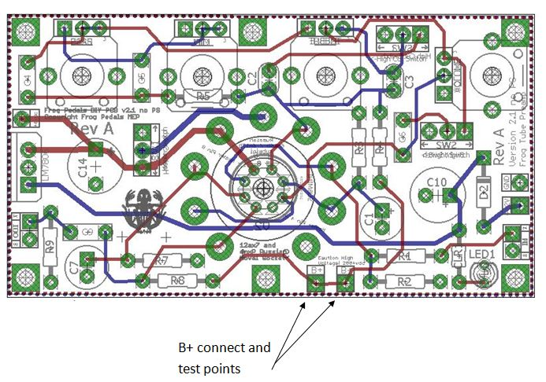
Power Supply (Source)
If you are using this as a second channel add-on board, you can get the High voltage power you need from the primary channel (2.0) board B+ test point. Connect the 2.1 add-on channel board B+ to the 2.0 board B+. Make sure you also have a common ground between the two boards.
Reminder: This voltage is no joke, and improper handling of the circuit can at the least knock you on your butt, and at worst could kill you. Always test the B+ test point (to left of R2 above) and a ground pad (standoff plated holes) with a volt/ohm meter for low/no voltage before handling!
Preamp Tube heater power source
I have provided for regulated 6 volt DC heater supply to eliminate hum that can be run with 9VDC or 12VDC. There is also a heater switching option, built into the PCB circuit so you can use almost any 12ax7 or 6NxP Russian (or western 6vdc heater) twin triode preamp tube.
There is also solder-able socketing for the Russian 6n16b/6n17b subminiature tubes which are used in military guidance systems for their ruggedness. Only the cathode resistor is different and you don’t need the heater switch. I have made this version with both a 6n16b and 6n17b Russian subminiature tube and it sounds great!
Russian Subminiature Vacuum tubes
You can also install a Mill-Max transistor socket in the Russian submini solderable socket. By doing that, you can install a 6n16b or 6n17b directly into the socket (no solder), or, solder a Mill-Max socket directly onto the subminature tube and then plug that into the board mounted Mill-Max socket just like the bigger preamp tubes. You should orient the bump on the Mill-Max socket to subminiature tube pin 1 for consistency.
See photos below:
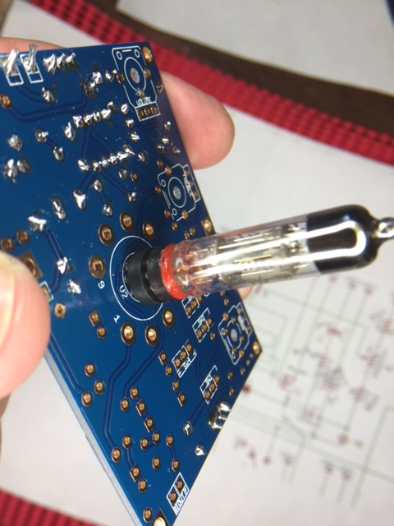
Refer to this link to learn how to orient the Russian Subminiature vacuum tube: http://frogpedals.com/wp-content/uploads/photo-gallery/RussianSubminiPinMarkingsdiagram.jpg
To “socketize” a subminiature tube, cut off the flying leads on the submini tube to about 6mm. Install with pin 1 or 5 oriented toward the Mill-Max socket bump for reference and straighten in Mill-Max socket (see bill of materials). Use extremely small tip soldering iron to solder into top of Mill-Max socket. I used high heat silicone to fill in between the tube and the Mill-Max socket. That will insulate the hot tube from the Mill-Max socket, damper the tube a bit and make it a little more robust for removal and re-insertion.
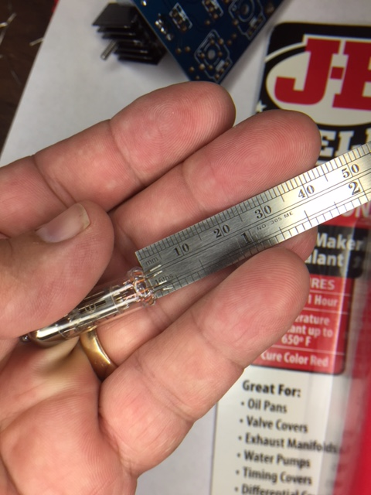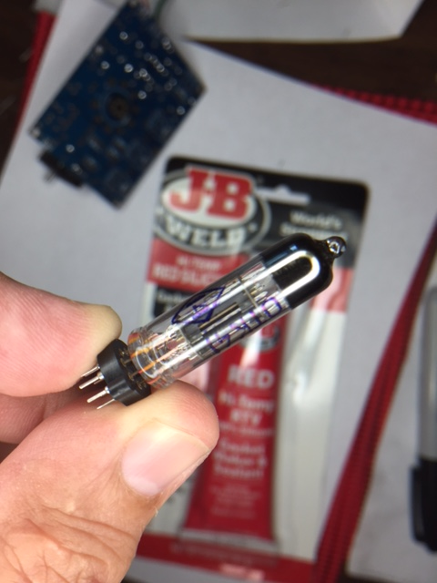
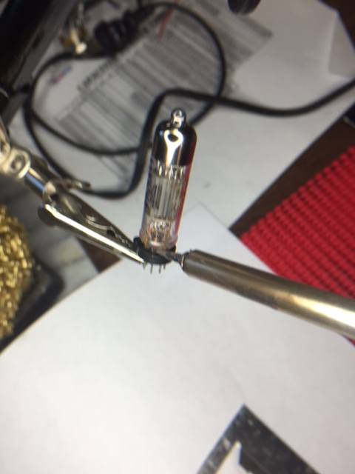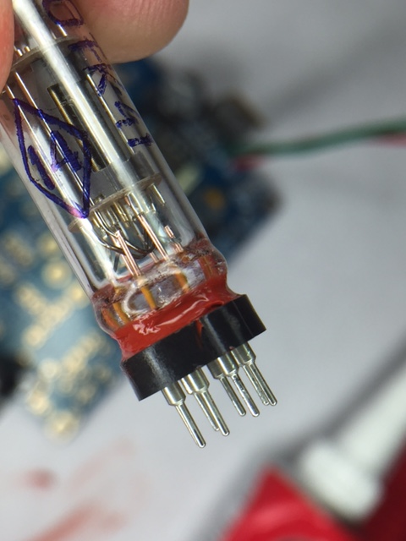

Compatible Preamp Tubes
Here is a list of preamp tubes I have used so-far:
- 12AX7
- 12AU7
- 12BH7
- 12AT7
- 6n1P Russian equivalent of 12AU7
- 6n2P Russian equivalent of 12AX7
- 6GA7
- 6n16/6n17b subminiature
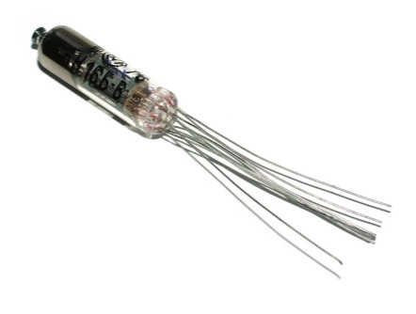
Tone
The original Fender bright switch is there with an additional switch added for high frequency cutoff. I love this option. With these switching configurations, it kind of gives you a rhythm/lead type of vibe.
You can use different components for the standard Fender or Marshall tone section if you want. These two tone stack configurations are listed in the bill of materials (BOM). Use the Duncan Amp Tone Stack Calculator to see how the different component selections (see BOM table sections later in this document) affect the frequency response.
Schematics
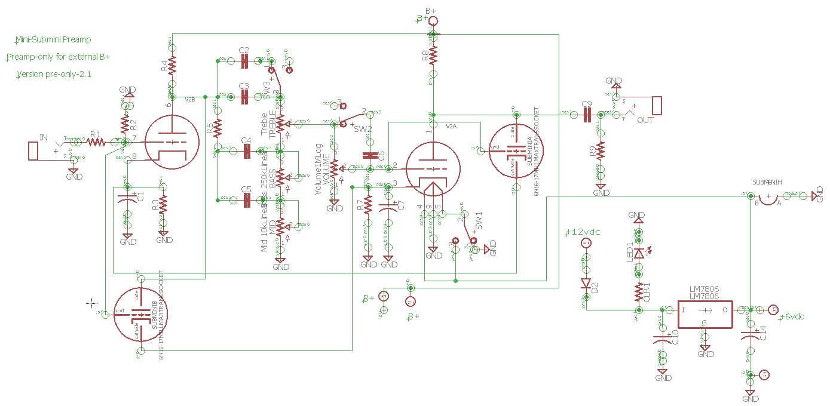
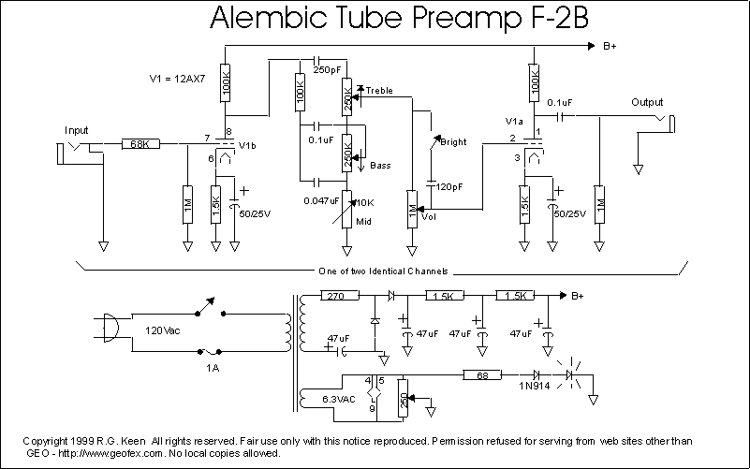

Bill of Materials (BOM)
Component | Ref ID | Suggested Source | Part # | Optional | Note 1 | Note 2
General Power Supply Components
1n5817 | D2 | Mouser | 512-1N5817 |  | For polarity protection
470uf 25v | C10 |  |  |  | 12 volt input power smoothing
DC Power Jack |  | BLMS or many others | Outtie Switched 2.1mm DC Power Jack |  | BLMS is Bitcheslovemyswitches.com,  Stupid name, nice prices
Toggle Switch for power |  | BLMS | SPDT - ON ON - LONG SHAFT - SOLDER LUG |  | Mounted off-board. Not needed for initial testing of preamp. I install during final build after enclosure drilled and painted | P/S
9-12 volt DC regulated Power Supply wall wart |  | BLMS | 9VDC Pedal Power Supply |  | It is best to get a negative center power supply transformer (wall wart) to be more compatible with your other pedals. Make sure it is at least 1 amp (1000ma). | P/S
Heater Power Supply
LM7806 | LM7806 | Mouser | 511-L7806CV-DG |  | 1.5 amp rated | Heater P/S
Small heatsink for above |  | Mouser/Ebay etc. | 567-274-3AB | Yes | Not needed if you mount LM7806 to enclosure | Heater P/S
100uf capacitor | C14 | Mouser | 598-107CKS035M |  | Electrolytic 16-35v | Heater P/S
Switch, On/Off - for Heater if needed | SW1 | Mouser | 10TC610 | Yes | Optional if you will only use 12Ax7 tubes or only use 6nxP Russian preamp tubes If you will only use one type of tubes, a jumper can be placed where the switch would be for the appropriate tube heater voltage | Misc
Miscellaneous
Light Plate |  | Small Bear |  | Yes | This is a very cool option | Misc
LED |  | Tayda |  | Yes | Choose your color | Misc
Resistor to limit LED current – 1K | CLR |  |  | Yes | Current Limiting Resistor. Adjust for desired brightness | Misc
Tube Guard |  | Home Depot! |  | Yes | Aluminum/Stainless Steel drawer pull. For a tube guard or actual tube gard (ebay.com) Example only | Misc
¼ inch Jacks | Input, Output | Mouser | 568-NYS229 |  | Get good jacks. CTC, Raen/Neutrik , etc. I have used cheap jacks but they aren’t as reliable | Preamp
Board Standoffs, screw type |  | Ebay |  |  | 10mm if you are using 9mm snap-in pots mounted on the board. | Misc
Stomp Switch |  | BLMS or Mammoth | 3PDT Footswitch Latched - Solder Lugs - BLUE |  | For signal bypass, but if this preamp is an “always-on” device, then, is not needed. For higher quality, go with the Mammoth “Pro” version | Misc
1590BB enclosure |  | BLMS  Tayda  Pedal Parts Plus | 1590BB or equivalent. |  | Many suppliers, paint however you wish, or get powder coated enclosure | Misc
Preamp and Tone Stack Circuit Components
Vacuum Tube |  | Many sources
Tube Socket, Noval PC Mount |  | Ebay.com | 9 pin Noval | Yes | Based on if you use a 12Ax7 type preamp tube. | Preamp
Mill Max socket for subminiature |  | Mouser | 575-91743208 | Yes | Based on if you intend to socketize a Russian subminiature tube | Preamp
68k resistor | R1 | Mouser |  |  | ¼ watt metal film | Preamp
1 Meg resistor | R2, R9 | Mouser |  |  |  | Preamp
100 K resistor | R4, R8 | Mouser |  |  | 1 watt metal film | Preamp
1.5 k resistor | R3, R7 | Mouser |  | Yes | ¼ watt metal film – 12Ax7 tube type – see below | Preamp
Or for subminiature tube build
1.8k resistor | R3, R7 | Mouser |  | Yes | ¼ watt metal film – 6n16b/6n17b subminiature tube type- see above | Preamp
47uf 25V | C1, C7 | Mouser
Not needed | C15 |  |  |  | Not needed – I skipped this number. | Preamp
.1 uf (100 nf) | C9 | Mouser | 505-MKS2F031001EKSSD |  | 180v minimum – blocks high voltage DC | Preamp
Bright switch ON/Off | SW2 | Mouser | 10TC610 |  | Sub mini (not mini) pc mount switch with bushing or not. Can be any size if wired off-board | Preamp
High cutoff switch On/Off | SW3 |  | 10TC610 |  | Sub mini (not mini) pc mount switch with bushing or not. Can be any size if wired off-board | Preamp
For Tone Stacks, Choose the Tone Stack Style and only purchase the required parts for that tone stack
Tone Stack Components Fender style
100k resistor | R5 | Mouser |  |  | ¼ watt metal film | Fender Tonestack
680 pf (high-cut) | C2 | Mouser |  |  | Ceramic disc, or film. 180v minimum – blocks high voltage DC | Fender Tonestack
250 pf | C3 | Mouser |  |  | Ceramic disc, or film. 180v minimum – blocks high voltage DC | Fender Tonestack
.1 uf (100 nf) | C4 | Mouser | 505-MKS2F031001EKSSD |  | 180v minimum – blocks high voltage DC | Fender Tonestack
.047uf (47nf) | C5 | Mouser | 667-ECQ-E2473KFW |  | Film or Box type. 180v minimum – blocks high voltage DC | Fender Tonestack
120 pf (bright) | C6 | Mouser |  |  | Ceramic disc, or film. 180v minimum – blocks high voltage DC | Fender Tonestack
B250k potentiometer | Treble, Bass | Tayda | SKU: A-1843 |  | Pots can be installed onboard, or off-board. Linear taper | Fender Tonestack
B10k potentiometer | Mid | Tayda | SKU: A-1847 |  | Pots can be installed onboard, or off-board. Linear taper | Fender Tonestack
A1Meg potentiometer | Volume | Tayda | SKU: A-1672 |  | Pots can be installed onboard, or off-board. Audio taper | Fender Tonestack
Tone Stack Components Marshall style
33k resistor | R5 | Mouser |  |  |  | Marshall Tonestack
680 pf (high-cut) | C2 | Mouser |  |  | Ceramic disc, or film. 180v minimum – blocks high voltage DC | Marshall Tonestack
470 pf | C3 | Mouser |  |  | Ceramic disc, or film. 180v minimum – blocks high voltage DC | Marshall Tonestack
22nf | C4 | Mouser | 505-MKP2G022201E00MS |  | Film or Box type. 180v minimum – blocks high voltage DC | Marshall Tonestack
22nf | C5 | Mouser | 505-MKP2G022201E00MS |  | Film or Box type. 180v minimum – blocks high voltage DC | Marshall Tonestack
120pf (bright) | C6 | Mouser
B250k potentiometer | Treble | Tayda | SKU: A-1843 |  | Pots can be installed onboard, or off-board. Linear taper | Marshall Tonestack
B1Meg potentiometer | Bass | Tayda | SKU: A-1882 |  | Pots can be installed onboard, or off-board. Linear taper | Marshall Tonestack
B25k potentiometer | Mid | Tayda | SKU: A-1857 |  | Pots can be installed onboard, or off-board. Linear taper | Marshall Tonestack
A1Meg potentiometer (volume) | Volume | Tayda | SKU: A-1672 |  | Pots can be installed onboard, or off-board. Audio taper | Marshall Tonestack

Suppliers
- Mouser.com – High quality parts, can be a bit more expensive, but the fewer sources you get parts from, the less shipping you will pay.
- PedalPartsPlus.com- I have not used them yet, but they are well regarded in the DIY pedal community.
- SmallBear-electronics.mybigcommerce.com – They have some unique parts. I like the “light plates”
- Taydaelectronics.com – cheap parts, but sometimes you get what you pay for. I use them as my primary source for 9mm pots, small resistors and other miscellaneous things.
- Bitcheslovemyswitches.com – I hate the name but they have good prices on switches and other parts. I especially like the 9 and 12 volt wall wart power transformers
DIY Resources
Madbeanpedals.com/forum is great if you need help, that is where I got started, DIYStompbox.com and Freestompboxes.org is great along with many other DIY guitar effect pedal websites and forums
Assumptions
- Many of the components listed above are my recommendation and what works for me. The suppliers are my suggested suppliers, but you can use any source as long as the component meets the specifications. Remember, you tend to get what you pay for.
- You should have a small tipped soldering iron (25-35 watt) for general soldering, for soldering in the submini tubes, I use the Weller WM120 Professional Solder Iron thin 12watt, 120 volt. Because it is expensive, I only use it for the submini tube soldering!
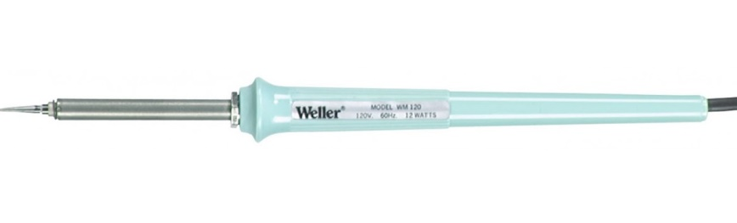
- Also you will need rosin core solder and project holder. Small gauge wire, #22-24 gauge, multiple colors preferred. Check out Barry's Best Hookup Wire at GuitarPCB.com for a good example.
- A 9 or 12 volt DC regulated power supply with center negative is required (see BOM above for example).

Primary power switching
I recommend a toggle or some other switch for powering on or off the unit. Because it takes about 10-15 seconds to warm up the tube’s heater, it is not practical to switch the unit on/off with a stomp switch. If you choose to use a stomp switch, I would use the stomp switch only for bypassing the signal and maybe a LED that indicates either:
- The signal is being run through the preamp, or,
- The signal is being bypassed around the preamp
Note: GuitarPCB (and many other DIY board PCB producers) has a great little board that mounts on a 3pdt stomp switch that allows you to use a common cathode bi-color LED that will do exactly what I described above. I have been using this board and it is very inexpensive and is easy to use. They provide good documentation with it as well.

Building instructions
Another few notes before you start
Again, despite its small size, once populated and powered up, this a serious, potentially dangerous build if you don’t use standard tube amp caution while handing this board. Always test the B+ test point with a volt-ohm meter for low/no voltage before handling! This could at the least knock you on your butt, or up to and including, kill you! Sorry, just had to remind you. I don’t want this to be the last guitar project you undertake (pun intended).

Test your components!
It is much easier to test components before you solder them rather than troubleshooting later. Using my volt-ohm meter (VOM), I test all resistors and caps. I have burned up a nice Aion Refractor PCB by putting an incorrect zener diode in (twice) because I trusted that the supplier put all the correct items in the bag. So double check polarized components and ensure they are placed on the board in the correct orientation.
Voltage regulator-important info
The mounting plates on the power regulator chips are set to the outside edge of the board to make it easier to mount to the enclosure or a heatsink. The LM7806 can be mounted directly to the enclosure or heatsink without an insulation kit because the metal tab of the regulator that has the mounting hole is equivalent to circuit ground.
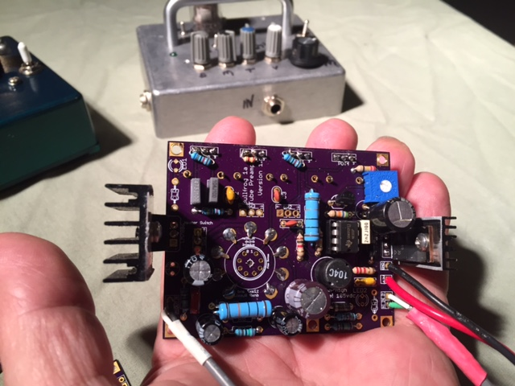 Prototype build with heatsink on both regulators left and right
Mounting the board in the enclosure
I have always used the actual PCB to determine hole locations. Using the bare PCB, lay it component side down and mark the mounting holes in the PCB you intend to use and the center of the tube socket hole (provided just for this purpose).
Populate in this order
- Diodes (not the clipping diodes)
- Resistors
- Capacitors
- voltage regulator
Always inspect each solder point for solder bridges. I use a lighted magnifying glass that attaches to my bench. Add the wires for +12vdc and ground and solder to the dc power jack.
Low Voltage Power Supply
For the low voltage, the first thing you will do is solder the LM7806 in the LM7806 component holes. For now, only solder part way into the holes so you have plenty of room to bend it over toward the enclosure for mounting or to give you plenty of room to mount the heatsink. The picture below illustrates how long I leave the leads on the regulator.
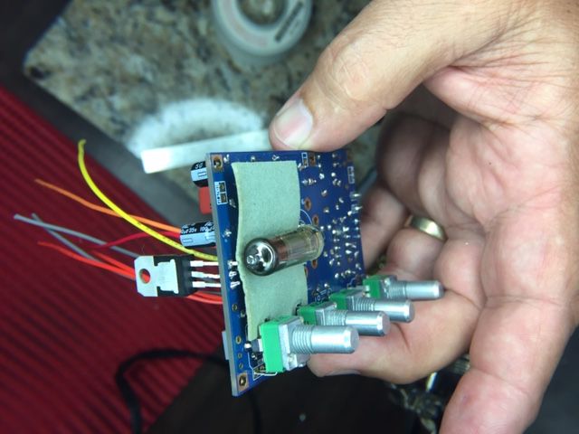 Bent over installation of Russian submini tube

If needed, you can reheat and move a bit lower later if needed. Solder the low voltage power supply capacitor (see BOM). Once again connect the 9-12vdc. Test the voltage on the lead toward where the pots will be soldered in. You should see around 5.8-6vdc. That is within specifications for the heater (usually 6.3vdc +/- 2%). Now the fun stuff!
Building the Preamp Section
Drill the Enclosure
Because of the small size of the board and how close together all the components are, you should mount the potentiometers off-board. I Also recommend that the bright and high cut switches be mounted off-board. If you mount them on-board, the potentiometers, switches and the preamp tube will be too close together!
Here is a quick list of items that may require a hole be drilled in the enclosure:
- Standoffs
- Pots
- switches (onboard and offboard)
- ¼ inch jacks
- stomp switch if used
- LEDs
- DC power jack
- 6vdc voltage regulator mounting hole if you are mounting it directly to the enclosure to dissipate heat instead of using a separate heatsink.
Drill the board standoffs and pot holes first and dry-fit the board with unsoldered pots first. If that looks good, then drill for the onboard switches you will be using and dry-fit them into the holes. Drill the LED holes and look down through to the PCB to make sure they line up fairly close.
Note: DO NOT get in a hurry and solder pots, switches, tube socket/or tube, or LEDs yet. You will regret it! Dry-fit only. We will solder them later at the proper time.
Once these are done, this will help you determine the best location for the DC power jack hole, off-board on/off switch and stomp switch hole until you have dry-fit the board onto the standoffs.
Use the PCB to determine the locations of many of the drill holes. Remember, if using the board as a drill template to mark the holes, place the component side (the side with all the components labeled) down, on top of the enclosure. You should see the pot outlines on this non-component side. The pots, the switches and the tube socket are all mounted to the non-component side. Drill holes for the standoff screws. You do not have to use all the standoff mounting holes. Make sure you use enough mounting holes to make sure to give the board a lot of support to insert or remove tubes if you are using a 12aX7 type tube socket.
Populating the preamp section The BOM lists two of the many different versions that can be built on this board. Choose your tone stack type (Fender or Marshall) and your tube type first (12ax7/6n1p or subminiature 6n16b/6n17b). This will list the specific components needed for that configuration.
Start populating the resistors first, box capacitors next, then electrolytic capacitors.
Next, on the non-component side of the PCB, add the tube socket (if using a standard 12ax7 type tube) or Mill Max socket if using a Russian subminiature tube. If using the 12Ax7 type tubeA, I fold over the pc mount contacts to hold it in place while soldering. Make sure the center hole of the socket stays aligned with the center hole in the PCB. Flood pc mount holes with solder so it will be strong enough to withstand insertion and removal of tubes. Put the power LED in its holes (unsoldered) taking care to orient based on the polarity of the LED holes.
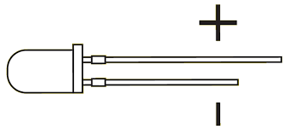 Thanks learn.sparkfun.com
Once the board is mounted solidly into the enclosure, put the mounting washers and nuts on the pots and on the switches and orient them properly
Testing the preamp
Before we begin
To test the preamp, the only PCB switch you need in place is the heater switch (or a jumper in place to replace it if you will use only 12Ax7 or 6nxP type tubes). No heater switch is required if you are using a subminiature tube. All the switches in one situation or another are optional.
If jumpering for using only one type of tube see the following illustration:
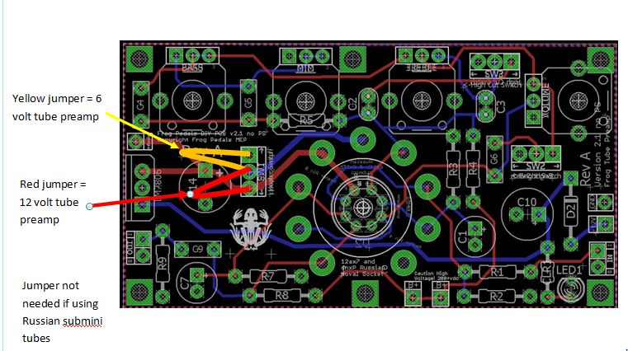
Jumpers are exaggerated to make them easier to see. They do not need to be long, just long enough to go from one hole to the other. Only one jumper allowed!
Connect PCB to High voltage power (example below shows connection to Frog Tube Preamp 2.0 PCB):
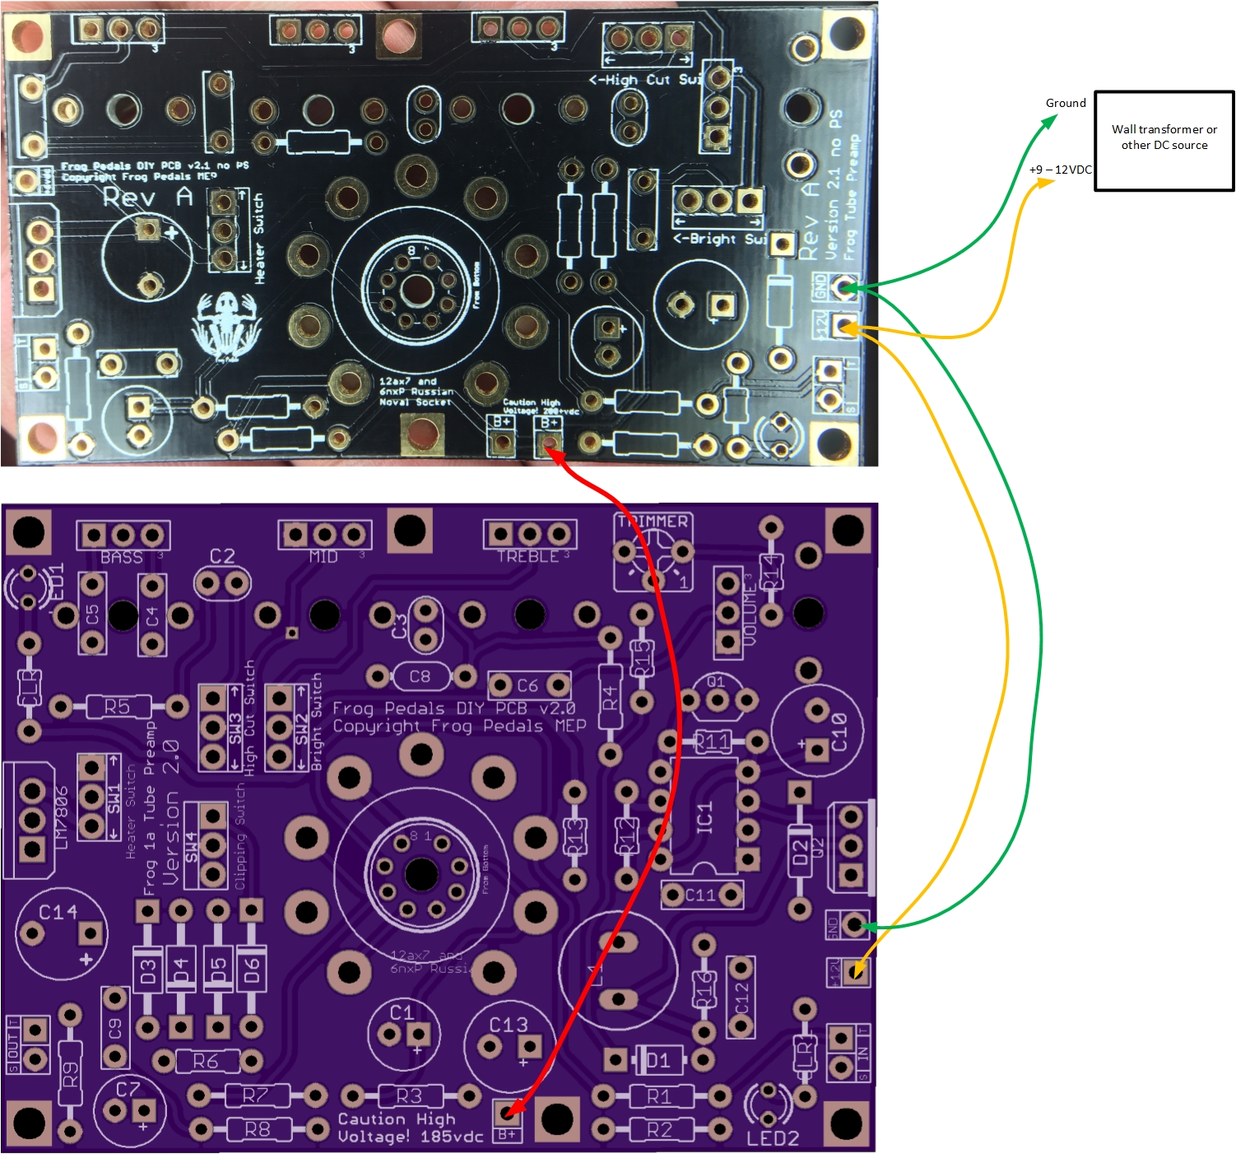
Note on diagram above: This is not a practical layout, but just to be used to show what pads, to connect to achieve high voltage from the 2.0 Frog Pedal (if that is the source of your high voltage). Make sure there is a ground connection shared between the boards also. Once they are connected together, adjust the trimmer on the 2.0 board for around 185VDC.
To test at this point it is fairly straight forward. You can temporarily connect it direct to the DC jack (without the switch for now) and can also connect wires to the In and Out pads on the board directly to ¼ inch audio jacks. The heater voltage regulator has a temperature protection built in. It will only work for a short time if it is not mounted on a heat sink of some kind, which can be the enclosure, so you have to make a decision whether or not test in the enclosure. Because of the high DC voltage, I recommend you mount the PCB in the enclosure. You are already probably used to taking it in and out already many times. Once the DC jack is connected (make sure it is center negative to be compatible with most of your other 9VDC pedals), turn all the controls to about ½ rotation or less. Place a preamp tube in the socket (12Ax7, etc.), connect to 9-12VDC wall wart, and the tube heater should begin to heat up within 5 to 10 seconds. Test the High Voltage B+ and reset to ~185VDC using the trimmer. Connect to an amplifier or a PA input. Keep all input volume/gain knobs on your amplifier or PA very low to start. Hook a guitar to your input. Play while slowly turning up the input volume on your amplifier or PA. I have found with this preamp, for normal operation, my input volume on the amp is kept very low and the same on the PA. This board can pump out the volume.
A word about noise and hum
Generally speaking, because the power supply is operating at between 30 -40khz, well above the 20khz hearing of typical humans, it should not produce noise into the preamplifier circuit, however, other things may, which include: routing of wires within the enclosure, bad or low quality guitar cables or wall transformer and, something that you can almost never avoid, hooking up a guitar. Single coils will be noisier than humbuckers because they don’t automatically cancel noise like humbuckers are designed to do. Proximity of a guitar or cables to a computer, heater, fluorescent light fixtures or a building with old, poorly implemented wiring system can all effect noise. What I have found on my prototypes is that they are pretty much noiseless. As you turn up the volume/gain, of course, any stray radio frequency being picked up from the environment via the cables or guitar can induce some noise.
Special instructions for subminiature tube installation (Russian 6n16b/6n17b)
There are three ways to approach a Russian subminiature vacuum tube build:
- Submini tube soldered directly into submini solder connection
- Mill Max transistor tube socket soldered into the board, submini tube leads cut to about 6mm and pressed directly into Mill Max socket.
- Mill Max transistor tube socket soldered into the board, Submini tube soldered into a second Mill Max socket, then that socketized submini tube is then plugged into first Mill Max socket soldered on-board.
If you choose to solder directly into the PCBS, this turns the project in some respects into an Expert level build. I have built using the Russian Sub-mini tubes, but getting the tube in correct is hard. In fact, I put a tube in 2 times incorrectly, so, make sure you are in a real good mood with lots of patience before starting this. Another thing is my regular soldering iron was way too fat to solder the submini tube correctly. I actually bought, just for this purpose, a small soldering iron I mentioned earlier under Assumptions, with an extremely small pointed tip. Once I did that, the soldering was quick and easy.
Another thing I have done with a submini tube build is to build it so it fits completely inside the enclosure, bent over underneath the PCB, so, the flying leads on the tube will each have to be custom bent and isolated from each other and I also added a piece of automotive gasket material to support the tube so it won’t vibrate against the PCB.
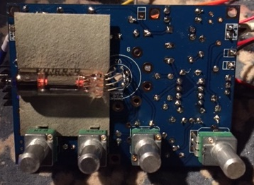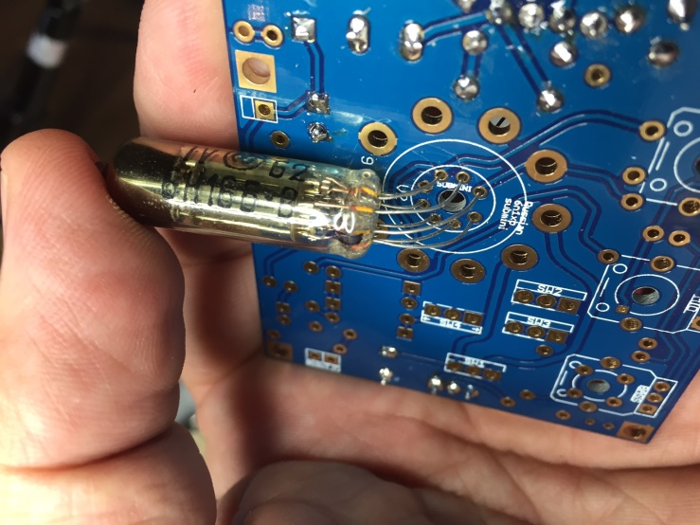

Below is a diagram to help you identify the leads before you put them in the holes. For now, if you put the leads in the holes, you don’t need to solder the two leads required for the tube heaters because they should make enough contact to light up the heater if it is oriented correctly. If it doesn’t light up, you can easily remove and re-orient the leads. I learned that after soldering it in and trying to remove it the first time. So, the power supply and the preamp board should be completely populated and ready to go before you solder this tube in place. The submini tube is soldered on the non-component side of the board. The same side as the pots and on-board switches are. The holes are numbered 1-8, but on the 2.0 version of the board, the numbers are on the component side, so as you look at the numbers, flip it over to the non-component side and mark with a marker, or nail polish the number one hole. The numbers do not directly correspond to the numbers of the bigger socket holes for the Noval socket.
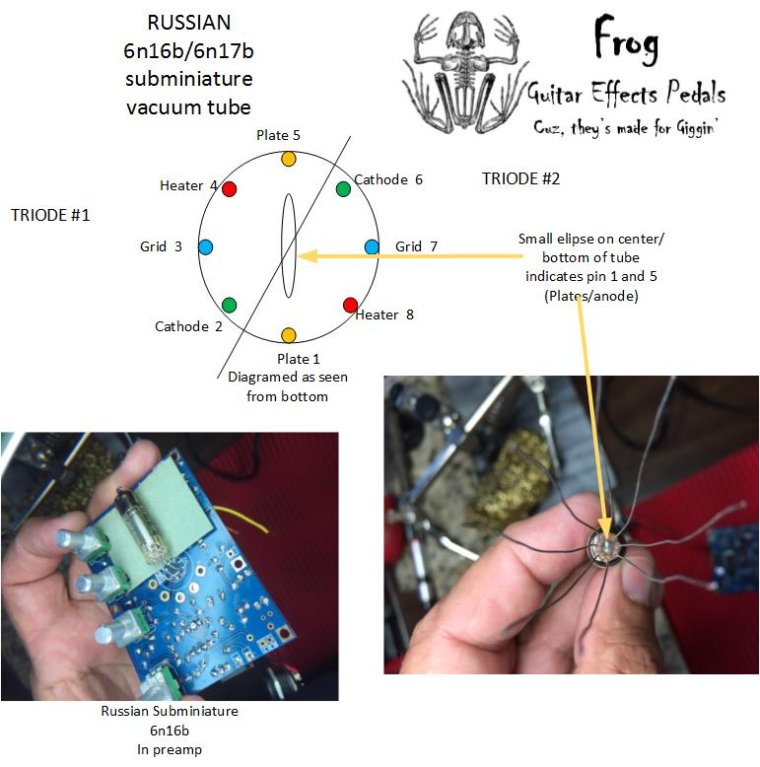

Disclaimers and License:
PCBs purchased from Frog Pedals are intended for DIY / non-commercial use. It is not allowed to redistribute the PCBs and/or artwork from this document, however, you can use these instructions and PCBs to build and sell your own product based on PCBs ordered from Frog Pedals. In buying the PCB discussed in this document, you agree to not use the product name Bullfrog or Frog Tube Preamp or any naming with Frog or Bullfrog in it as a reference to your product. If you have any specific questions regarding this disclaimer or license, please contact Mark Price at mark@frogpedals.com
Another disclaimer: Don’t produce for sale before you read this: Because of the nature of the SMPS power supply used on this device it is subject to FCC rules and regulations. The technology used to get the high DC voltage, requires the power supply operate between 30 and 40Khz. FCC certification of this before commercial sale is required. Electro Harmonix paid dearly for ignoring this. See this article for more information: New Sensor (Electro Harmonix) FCC Compliance Guide

